**Team 2’s Group Project Overview**

Ginger All The Way

**For Presentation on January 11, 2024**

# Overview

We created a Christmas baking recipe website for kids that would be user-friendly, easy to navigate, engaging, accessible for all users and tasteful in design.

Git Repository - <https://github.com/Cristina-Pat/gingerAllTheWay>

Git Page - [https://cristina-pat.github.io/gingerAllTheWay/index.html#](https://cristina-pat.github.io/gingerAllTheWay/index.html)

# Goals

1. **A sleek and modern feel:** Our website inspiration (https://braise.qodeinteractive.com/ ) had a sleek and modern feel, which we tried to replicate whilst creating a unique branding that best suited our theme as a Christmas kids recipe site, with Christmas colour accents, fun images and user-interaction.
2. **Accessibility:** This was one of our most important goals to provide a quality experience for all users, so we prioritised making UX/UI design choices that would best reflect this.

# Specifications

# 

# Milestones

## Creating wireframes

As a team, we discussed and decided on which team members were responsible for each site page. Following this, we each created some basic wireframes for them to plan what elements we would like to aim to include. Overall, we succeeded in this goal of including most of our planned elements but were quite ambitious so there were some wireframe elements which we were not able to complete on time.

<https://github.com/Cristina-Pat/gingerAllTheWay/tree/main/wireframes>

## Ensuring maximum accessibility and visibility

When making decisions for our UI/UX design, we made sure the aesthetics of the page were not lost to visually impaired users by opting for a minimal design with small accents of colour. We did this by selecting a Christmas-themed colour scheme which passed all contrast ratio and colour blindness tests using the Adobe Color website tools.

Focus was put on increasing readability by selecting a suitable font choice. After researching using the UK Home Office’s Guide to Accessibility and other guides, we decided on a fun stylistic font with a hand-made cosy feel for our logo and website title(‘Candy Cane’), and a clear, easy-to-read but engaging font for our main text (‘Lexend Deca’). 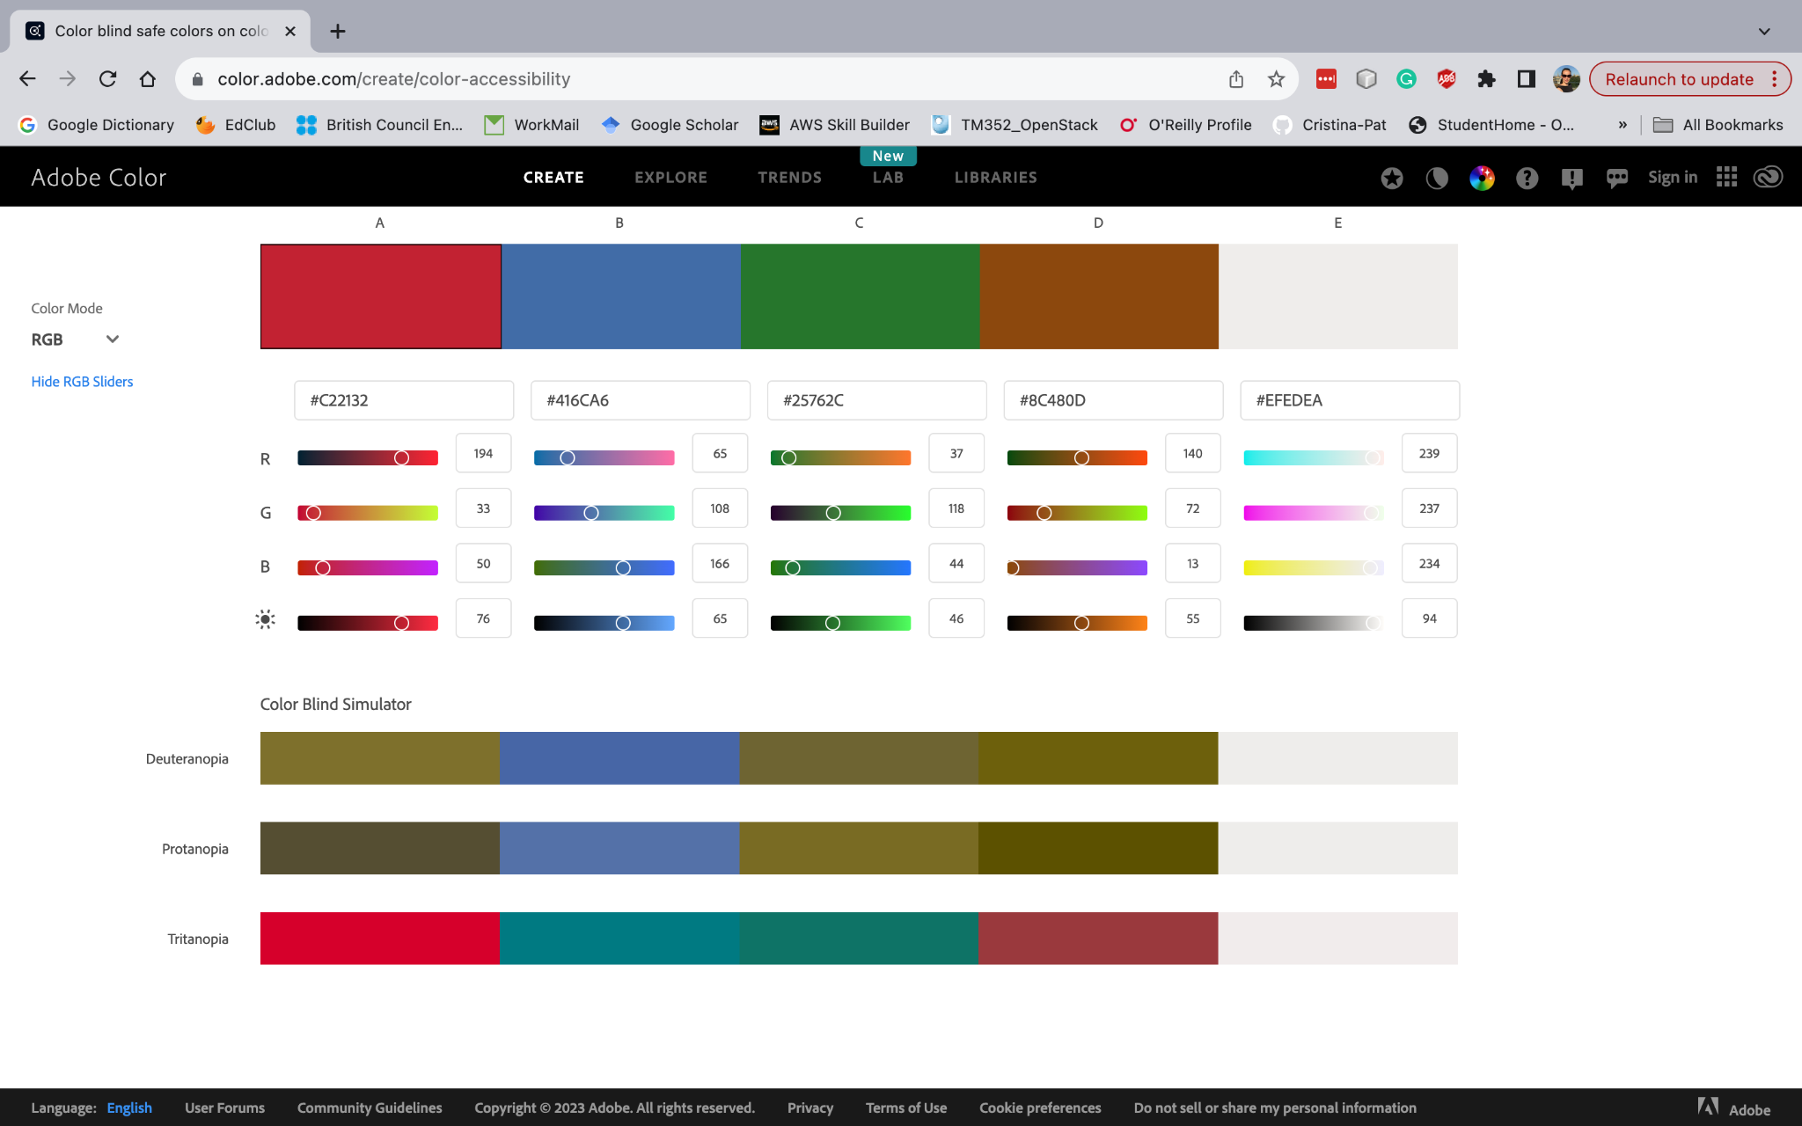

Making the site engaging

We made sure to include features of user interaction in our pages, such as a navigation bar with dropdown menus, fun images that zoom on mouse hover, automatic image carousels and arrows for clicking through shopping list items.

# Team Member Reflections on the Project:

## **Cristina Pat**

When designing and coding my page, I consider the following aspects:

1. Creating a design that aligns with users’ needs using wireframes.
2. Enhancing accessibility in coding the page by incorporating:

* A clear and logical structure for the webpage.
* Using descriptive and meaningful text for links, buttons, and images.
* Maintaining sufficient colour contrast between text and background to accommodate users with visual impairments.
* Implementing a responsive design that adapts to various screen sizes and devices.

While most elements from the wireframe are incorporated into the website, I ran out of time and could not complete the “About Us” section. For the next project, I will try to better organise my time, allocate additional time for researching how to implement specific features using new technologies and prioritise tasks effectively.

## **Laura Lees**

My reflection on the project is that it was both challenging and rewarding. Our team was able to create a website with:

* A user-friendly interface with clearly designated sections, for example, for each aspect of the recipe, for ease of use
* A choice of colour palette that is highly accessible and colour-tested to increase readability for visually impaired users

I am proud that through this project, I was able to succeed in creating:

* Fun and engaging elements on my page, such as an image that zooms on mouse hover and mini illustrations related to each step in the recipe directions
* I was able to create an aesthetically pleasing page to contribute to our group's final site. Despite challenges in its creation, I was able to make a page with most of the elements designated in my initial wireframe and style it to how I planned.

My main takeaways for improvements would be to:

* Work on more clearly organizing my code sections through the use of clear and relevant div class and id names and to improve my use of JavaScript, as my plan to create an interactive ingredients list that would update on user input did not work.

## 

## **Princess Reginald**

Improvements:

* I noticed an improvement in my html structure, through the use of div and ids for classifying different parts of my code.

What I could improve on:

* my use of css, and JavaScript. They could have a bit more depth to ensure that my code is functioning properly. E.g my JavaScript hardly works

What I accomplished:

* I managed to add a few functionalities to my website, like the hovering button on the image and the scrolling arrow. By using CSS, I have it more structure than a few words on a blank page.
* It has the general layout of a shopping webpage and through my experience I can create a better model
* What I failed at— JavaScript functionality and actualising my wireframe